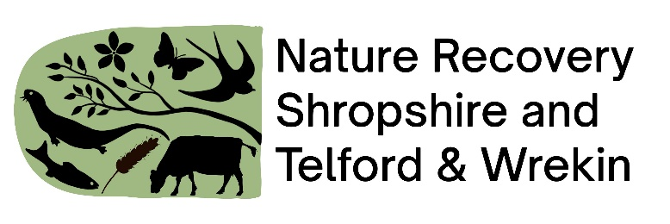

**SMALL WORKING GROUP session on 6th December**

**SALC/LNRS conference – from 4-4.30pm facilitated by Lynn Parker – County LNRS lead**

Thanks to everyone who attended this session, it was wonderful to see so many still keen to join the discussion. The notes below form a summary of what was discussed and also includes notes provided via the feedback form.

These suggestions for how T&PCs can be supported to help enhance nature in their areas will be considered as the priorities for the LNRS are developed. The reality is that many require additional funds and mechanisms to lever these in, so options will need to be considered. However, in the meantime, much support could potentially be provided by enabling people to share information, resources and ideas, and this is something the LNRS and SALC will discuss.

Questions for Town and Parish Councils & Local Nature Recovery Strategy

1. What support would you need to take action on nature recovery?

**Advice**

* Ecological advice
* Advice on how to get help from the Council
* Direct access to records
* What’s the first step
* It’s rural and green, it’s fine
* How to Guide e.g. Bishops Castle Goes Wild toolkit
* Examples documents e.g. biodiversity policy, local biodiversity plans

**Feedback** along the process – where to start and then how to adapt/refine

**Contact list** of organisations that are able to provide help e.g. CPRE, Caring for God’s Acre, Shropshire Botanical Society, ponds, leaky dams etc. Make it clear who to ask for help e.g. maps (inc info on licenses)

Production of resident friendly **maps**

**Funding**

* How to access
* If you spend £x it will get you this – a shopping list with outline prices
* How to set up a £100(?) grant facility
* Funding to finance expertise and ecological/biodiversity surveys on identified town council sites, along with action plan for these sites
* Funding and expertise to support the delivery of key actions that have been identified
* Community funding to support key partners to reach their biodiversity aims and objections and to further enhance resident interest and connection.
* For staff time to co-ordinate volunteer efforts

**Communication** is essential

* Parish councils need support to enable them to communicate their bio-diversity plans to their residents
* example leaflets
* example newsletter articles
* outline comms plan
* best practice in working with farmers
* how to bring all the community together

**Support** to establish regular **formal contact between local green groups and T&PC’s** to improve understanding of issues and work together as a partnership

**Training** for grounds maintenance staff

**Collaboration**

* share information / resources
* economies of scales for procurement
* consider pooling the precept / funds
* sharing best practice between communities who are learning and delivering
* how have others engaged more people
* Admin support for paperwork (for PC and landowners and interested parties)
* Task force to liaise between landowners and PCs

**Specific ideas**

* **Hedgerows** connect up landscapes like rivers do; they are links in a chain; and they also connect up people and communities Helping to improve local hedgerow management as well as do lots of creation, ideally including hedgerow trees – as well as improving verge and ditch management - that would go some way to recovering nature locally in many different ways and get trees/good grassland back into our landscape without taking up too much productive/growing land.
* **Start small and work outwards.** Consider private gardens and churchyards.
* Potential opportunity as a pull to draw in new councillors
* Ambition – every PC to have a nature reserve
* Set up a funding mechanism ring fenced for nature

1. What are the barriers to Town & Parish councils to taking action?

Fear of change

Shropshire Council. Over bureaucratisation of borough council procedures and policies

Lots of priorities for T&PCs, nature recovery is one of many

A reluctance in some T&PCs to engage with SALC LNRS conferences and local green space groups, leading to a lack of education and understanding on the important issues

Committed, but not ecologically trained, reliant on the knowledge of partners and their volunteer time to support delivery.

**Funding and resources**

* The LNRS will only get full buy in if its viable. Linking grant opportunities is key.
* Most maintenance budgets are limited and generally restricted to managing urban areas and formal parks. Habitats are seen as optional or not fully considered
* Capacity of volunteers, small pool of people (and households for some parishes)
* Small number of households so smaller amount of money possible from a precept
* A small amount of resource to fund baseline survey work and recommendations
* Resource to further support the delivery of those actions (expertise, funding, finance and time)
* Additional resource is necessary to really achieve what we would like to on our land and with the community.
* Provide support to group leaders and enable more people with the potential to become volunteer leaders to do so.

**Knowledge:**

* Lack of acknowledgement / understanding that there is a problem – it’s all green in the countryside
* Staff and volunteers may lack the knowledge required to understand the habitats and species that can be supported in their areas and open spaces.
* Not knowing where to access guidance and support from existing bodies and organisations.

**Maps and land information**

* Proper mapping exercise to identify landownership
* Knowledge bank of ownership and past environmental use