Lo 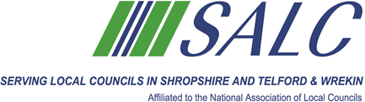

**Celebrating over 70 Years serving Parish and Town Councils in Shropshire**

**Calling all**

**Long Standing Officers**

How long have you been working as a Clerk/Officer

If you have been a Parish/Town Clerk for over 20 years or longer, not necessarily to the same Council, we would like to hear from you.

At our AGM on 30th October 2024, Clerks who have served for 20 years or longer will receive a presentation (20 Years’– bronze award, 25 (silver), 30 (gold) and 40 (platinum).

Please fill in the details below and return to:-

SALC, Shirehall, Abbey Foregate, Shrewsbury SY2 6ND, or email [alc@shropshire.gov.uk](mailto:alc@shropshire.gov.uk) to be received no later than 11th October 2024.

……………………………..

|  |  |  |  |  |
| --- | --- | --- | --- | --- |
| Name of Officer/Clerk | Name of Current Council | Contact Details | Are you attending the AGM Yes/No | No of years Service |
|  |  |  |  |  |