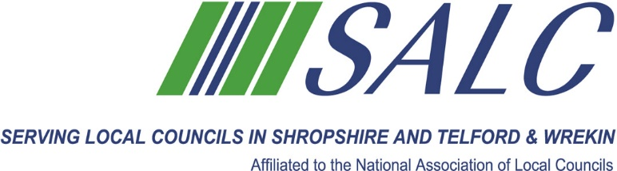

**Celebrating over70 Years serving Parish and Town Councils in Shropshire, Telford & Wrekin**

**President’s Achievement AWARD 2024**

**This is awarded to a Town or Parish Council who has over the last 3 years accomplished a significant improvement for their local community.**

**Do you feel your Town or Parish Council has achieved something extra special during this period?**

**Have you achieved Local Council Award Scheme Status?**

**Provided an extra service for your Parishioners?**

**Have you worked in partnership in any particular project e.g. rebuilding your Village Hall?**

**Or is there anything else that you feel your Town or Parish Council deserves to be recognised for in 2024?**

**Please forward applications for this prestigious award to SALC, Shirehall, Abbey Foregate, Shrewsbury SY2 6ND, (or email** [**alc@shropshire.gov.uk**](mailto:alc@shropshire.gov.uk)**) to be received no later than 11th October 2024. This Award will be presented at the AGM on 30th October 2024.**

**✂………………………………………………………………✂**

**Name of Parish Council…………………………………………………………...............**

**Contact person name …………………………………… Phone no. ………………………**

**Brief outline of your project………………………………………………………………..................**

**………………………………………………………………………………………………...........**

**……………………………………………………………………………………………………………………………………………………………………………………………….........................**

**………………………………………………………………………………………………………………………………………………………………………………………………………………………………………………………………………………………………………………………………**

**Continue on additional page if necessary………………………………………….**